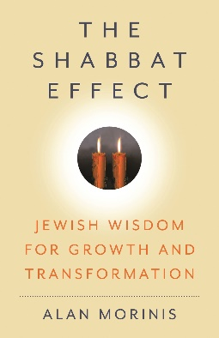
The Shabbat Effect
Jewish Wisdom for Growth and Transformation
By Alan Morinis

One of the most important biblical mandates, so significant as to number among the Ten Commandments, is the directive to observe a weekly day of rest. The Shabbat Effect illuminates how the practice of a day set aside for rest can bring about a deep, lasting, and pervasive spiritual illumination and transformation of character, not just on that seventh day but every day of your life.

ALAN MORINIS WILL BE SPEAKING ABOUT HIS NEW BOOK THE SHABBAT EFFECT:

DATE:

TIME:

LOCATION:
Drawing on venerable sources from the 1,100-year-old Jewish tradition of Mussar as well as the experiences of contemporary practitioners, Alan will explore how the practice of Shabbat enhances and refines core traits of character. His teaching will illuminate a path to living a life that is not only more enjoyable but also leads to fulfilling your highest human potential.

Alan Morinis, PhD, founded The Mussar Institute in 2004 and is a leading figure in the contemporary revival of the Mussar movement. A Rhodes Scholar and an anthropologist, he became a student of the late Rabbi Yechiel Perr, an accomplished master of the Mussar tradition. Following years of study, he reinterpreted the ancient Mussar learnings and practices for modern audiences in Climbing Jacob’s Ladder (2002); Everyday Holiness (2007); Every Day, Holy Day (2010); and With Heart in Mind (2014).

Praise for The Shabbat Effect:
“Bolstering the narrative with valuable prompts to help believers track their progress, the author meaningfully frames Shabbat as a lens through which readers can zoom in on what matters, “scrutinize” their spiritual challenges, and carry the resulting lessons into their daily lives. It’s a lucid guide to reinvigorating an ancient religious practice.” — Publishers Weekly

“The Shabbat Effect is a tome to be read slowly and remembered.”— Booklist

"The Shabbat Effect shines in its accessibility, with Morinis’s warm, jargon-free style making complex spiritual ideas relatable to Jews and non-Jews alike." — San Diego Jewish World

The Shabbat Effect: Jewish Wisdom for Growth and Transformation
https://mussarinstitute.org/the-shabbat-effect/

Published November 13, 2025 • ISBN: 9798881807870 • Hardback • $30.00 • 192 pages

